Thinking about trying out a plant-based food and want to know more?
Plant-based diet is a way of eating that celebrates plant foods and cuts out unhealthy items like added sugars and refined grains. Studies suggest that Plant-based diets have been linked to number of health benefits, including reducing your risk of heart disease, certain cancers, obesity, diabetes and cognitive decline. Additionally, eating more vegetables, fruits, grains, and pulses maximizes nutrient intake and virtually eliminates foods that can lead to poor health outcomes.

Here are a couple of delicious and quick plant-based recipe ideas that you may find useful.
Lentil & Tomato Dal
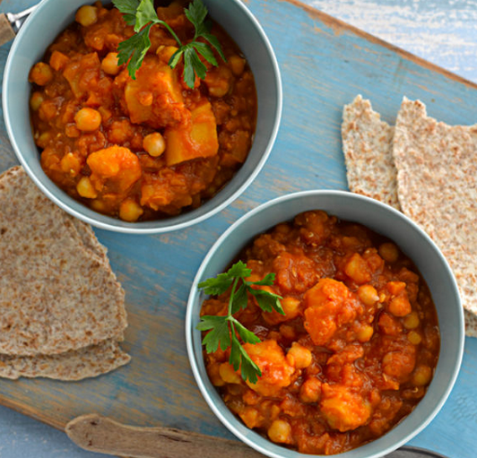
Ingredients:
1 tbsp olive oil
1 medium onion, finely chopped
1 clove garlic, crushed
1 inch piece ginger, peeled and grated
1 large carrot, peeled and diced into small pieces
1 large potato, peeled and diced into small pieces
1 tsp ground cumin
100g red lentils, rinsed
600ml low sodium vegetable stock
400ml passata
1 x 210g can chickpeas, drained and rinsed
1 tbsp lemon juice
Pinch of ground black pepper
1 wholemeal roti
Method:
Heat the oil in a large saucepan. Add the onion, garlic and ginger and fry gently for 5 minutes.
Add the carrot, potato, cumin, lentils, stock and passata to the pan. Bring to the boil then turn heat down to a simmer.
Cover the pan and cook for 20 minutes, stirring occasionally.
Add the chickpeas, and more water if needed, and cook for a further 20 minutes, continuing to stir from time to time.
Ladle the dal into bowls and top with a squeeze of lemon juice and a little black pepper.
Serve with wholemeal roti.

Veggie Burger
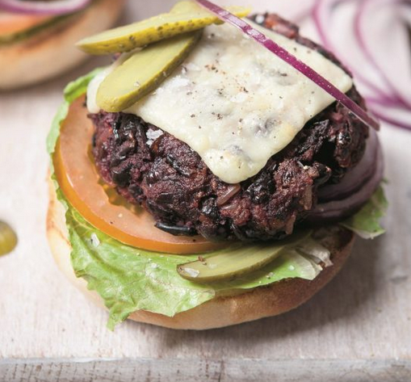

Ingredients:
1 tsp vegetable oil
1 red onion, finely chopped
2 garlic cloves, finely chopped
2 x 400g cans of black beans, roughly mashed
100g cooked brown rice
2 small cooked beetroots, coarsely grated
1 tbsp tomato purée
1 tbsp mushroom ketchup
1 tsp soy sauce
1 tsp onion powder
50g fine breadcrumbs
Sea salt and black pepper

To cook and serve
Low-cal oil spray
8 slices of reduced-fat hard cheese, optional
8 burger buns
Lettuce leaves
2 tomatoes, sliced
1 red onion, sliced
Gherkins, sliced
Method:
Heat the oil in a frying pan, add the onion and cook until it’s very soft and lightly caramelised. Add the garlic and cook for another couple of minutes, then take the pan off the heat, tip the onion and garlic into a bowl and leave them to cool.
Add the remaining burger ingredients to the cooled onion and garlic. Season well with salt and pepper, then put the mixture in the fridge to chill for a couple of hours. Shape the mixture into 8 patties weighing about 100g each, then put them in the fridge again until you are ready to cook. You can also freeze the burgers at this stage: open freeze them until firm, then transfer them to a freezer-proof container.
When you are ready to cook the burgers, preheat the oven to 200°C / gas mark 6. Spray a baking tray with low-cal oil. Arrange the burgers on the baking tray, spray them with a little low-cal oil, then bake them for 20 minutes. If using cheese, add it for the last 3 to 4 minutes of the cooking time.
Lightly toast the burger buns, then layer up the burgers with the salad ingredients and any condiments you like. You could also add smoked tofu to your burgers instead of cheese.

